**PORTLAND PROJECT**

**PORTLAND CENTER PLAZA**

**THE LINC**



**SUNDAY, MAY 10th , 2020**

6:30 AM On shift. Relieved Officer Aguilar and Officer Paul.

7:00 AM Initiated walking patrol of the PCP surrounding storefronts and garbage areas. No issues to report.

7:30 AM Continued walking the Linc apartment garbage areas, pool / gym areas, and parking areas. No issues detected.

8:00 AM Positioned vehicle in PCP parking area for continued surveillance. No problems at the moment.

9:00 AM Conducted vehicle patrol of the Linc apartment perimeter and looked for signs of non-residents on property. some people were walking outside, but no reason to suspect any issues.

10:00 AM Continued surveying the outside of the PCP storefronts. No issues present at this time.

10:45 AM Conducted a walking patrol behind the PCP storefronts. No issues detected.

11:30 AM Began another patrol from PCP to Linc apartments and came upon an individual with multiple bags spread across the concrete. Face tattoo, ball cap, and canine companion. I let them know there was no loitering and he let me know he was just waiting for a friend. There was no issue and they eventually moved on. I finished my patrol of Linc pool and gym area.

12:00 PM Checked on Plaid Pantry. Everything appeared calm and the clerk reported no issues during his shift.

12:30 PM Positioned vehicle in the PCP parking area for continued surveillance.

1:00 PM Started another walking patrol of the PCP garbage and walking areas. No issues detected. Then checked the North perimeter of the Linc parking garage. There were skateboarders in the area, but off property.

1:30 PM Again returned to my station in the PCP parking lot.

2:30 PM Moved vehicle station to the outside of Linc on the South side near the pool area and max station. Decided to keep an eye out for our notable individual from yesterday.

3:00 PM Initiated a walking patrol near Plaid and the Liquor Store. No issues present at this time.

3:30 PM Continued surveillance of the Linc Apartment entryway. Moderate foot traffic from around the West side walking areas, but otherwise no issues.

4:00 PM initiated vehicle patrol of the PCP parking area. Things still appeared calm and free of problems at this time.

4:30 PM Began a walking patrol of the Linc apartment perimeter starting from the North parking garage. On the way there, I found someone who had just began falling asleep with a sleeping bag and open container. I told them to move on (pictured below). I then continued to the west walkway and checked for transients and other illegal activity. Nothing was detected at this time. 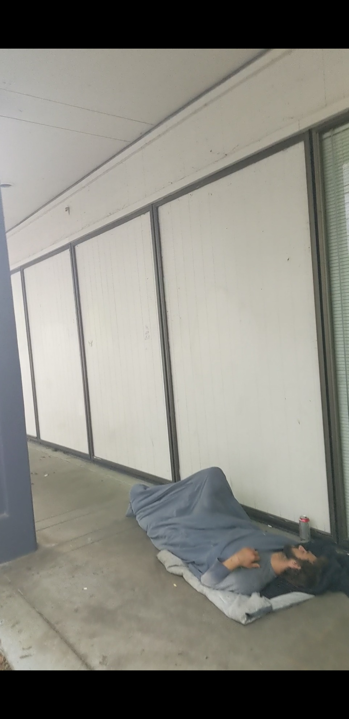

5:05 PM While returning from patrol and arriving in the PCP parking area I noticed a damaged window from far away. Located at the bookstore storefront. I quickly parked and went to further investigate. When approaching, it became clear that there was significant damage to the window. I went to check with the Plaid Pantry clerk in hopes that she witnessed the event. She did see the man that caused the damage, and said it was seemingly an accident, but then he left the scene. This happened 5-8 minutes prior to my arrival according to her. I didn’t receive any phone call about the incident occurring, which was unfortunate, but I let her know that that’s definitely something I want to be informed about immediately if possible in the future.

I pulled some video from their security camera footage which showed the reaction of the man after he caused the damage (pictured below). His gestures seemed to suggest it was not intentional, but I assumed it could have been avoided if they were careful of the property. The individual appeared transient with a sleeveless brown shirt and brown short hair. White male, approximately 28-30 years old. I immediately reported the damage to Supervisor King, and sent picture evidence to Jamie over the site phone. At this point, I patrolled the surrounding areas for a sign of the individual after he headed West.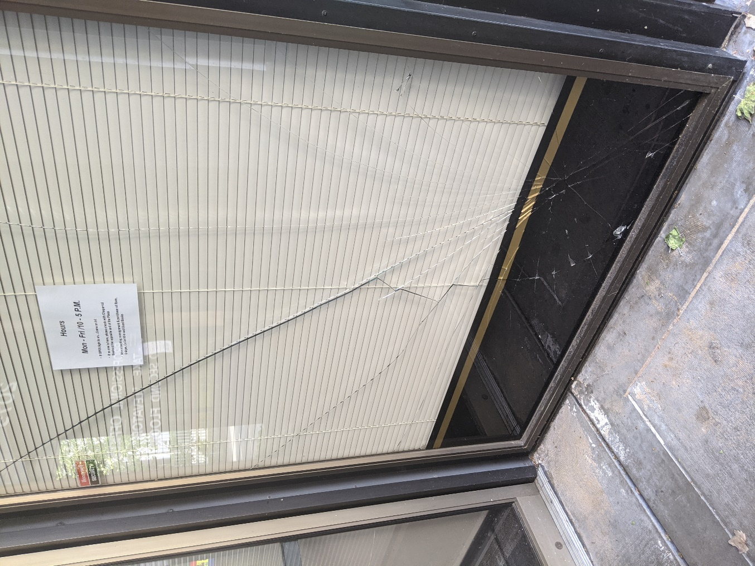

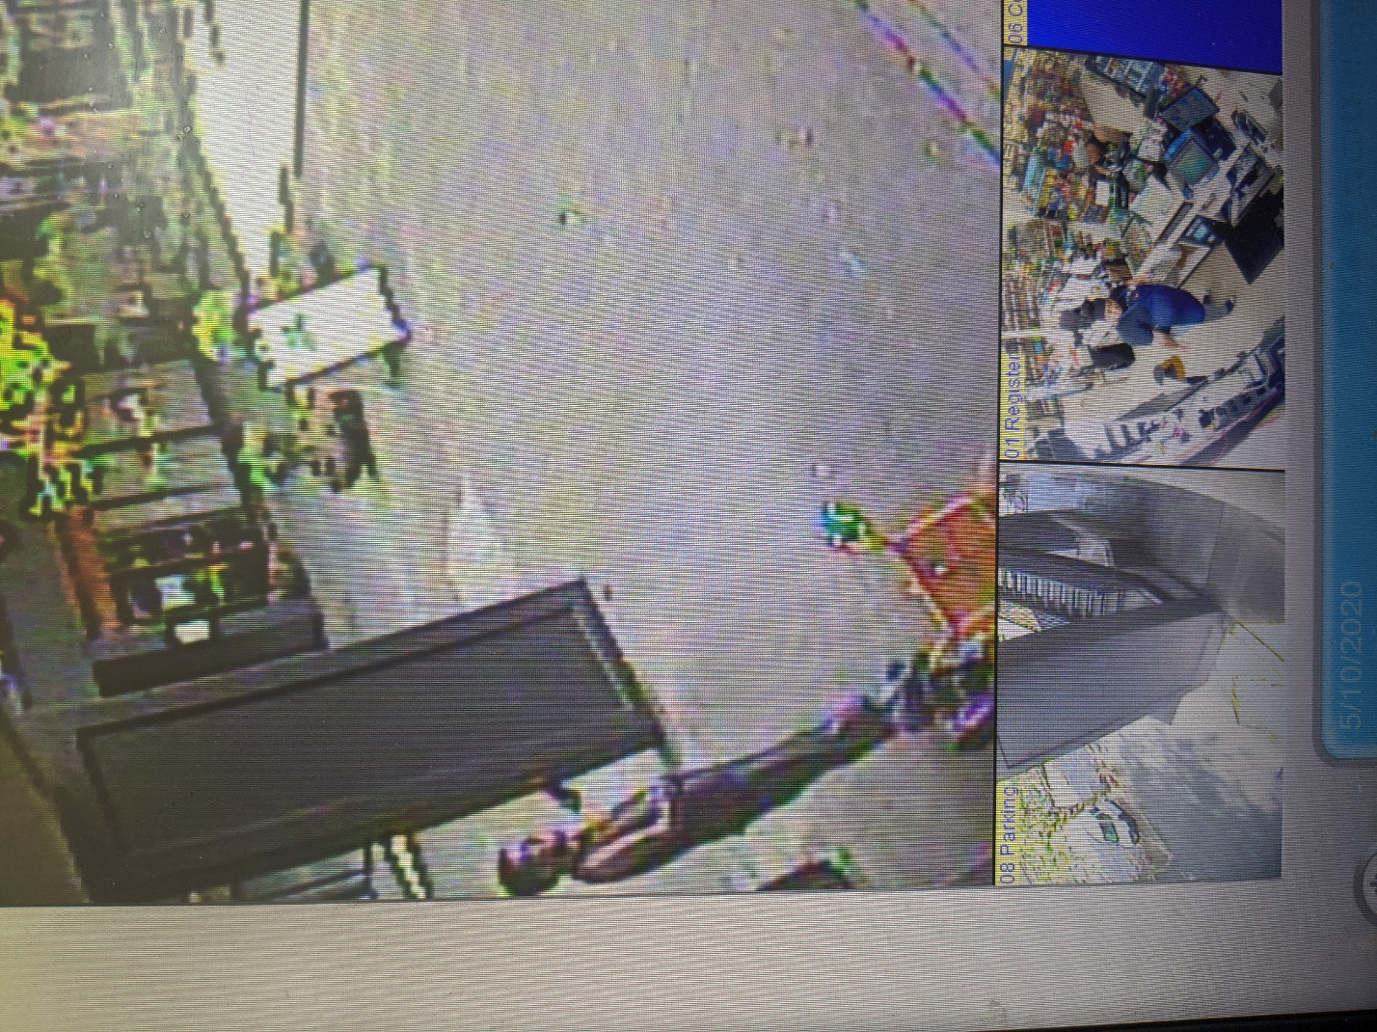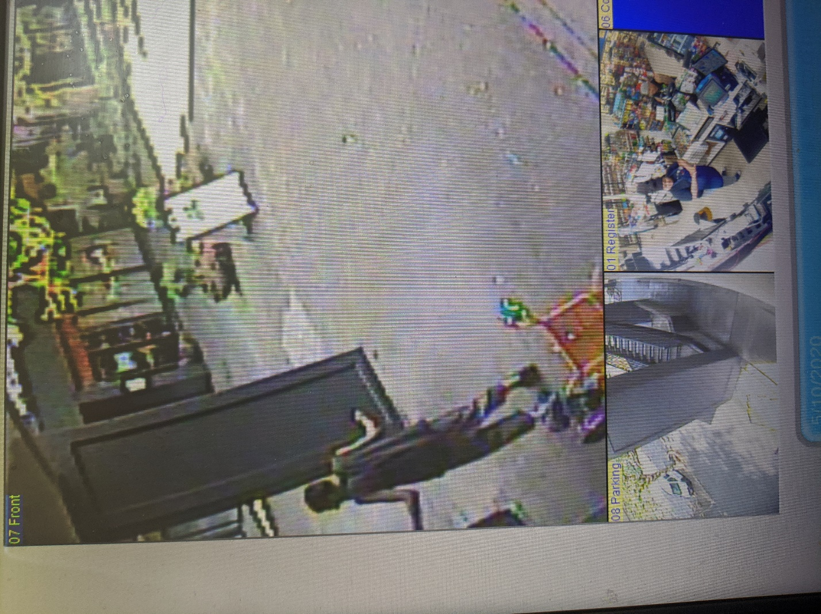

6:00 PM After several patrols of surrounding parks and PSU campus, I found no sign of the individual. At this point I returned to the PCP office to brief Officer Aguilar on the events.

6:30 PM Off Duty.

**\*\*\*\*\*\*\*\*\*\*\*\*\*\*\*\*\*\*\*\*\*\*\*\*\*\*\*\*\*END OF REPORT\*\*\*\*\*\*\*\*\*\*\*\*\*\*\*\*\*\*\*\*\*\*\*\*\*\*\*\*\*\*\***